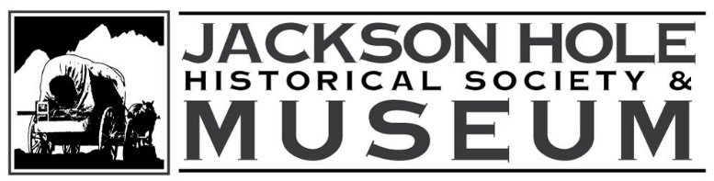 Press Release
For Immediate Release
September 10, 2013
Contact: Dr. Sharon Kahin
733-2414
skahin@jacksonholehistory.org
www.jacksonholehistory.org
_____________________________________________

CALENDAR: Voices of the Valley program featuring author Rev. Warren Murphy who will discuss his recent book On Sacred Ground: A Religious and Spiritual History of Wyoming on Thursday, September 19, 2013 at 7:00 p.m. at 225 N. Cache in the museum gallery. www.jacksonholehistory.org. 733-2414.
_____________________________________________

Voices of the Valley Program “On Sacred Ground” Offers New Insight into Jackson and Wyoming History

Rev. Warren Murphy of Cody will be the speaker for the Jackson Hole Historical Society and Museum’s Voices of the Valley program series on Thursday, September 19th. Rev. Murphy will also be offering a book signing of his recent work, On Sacred Ground: A Religious and Spiritual History of Wyoming — winner of the 2011-12 Non-fiction History Award from the Wyoming Historical Society. The program will begin at 7:00 p.m. at the 225 N. Cache museum gallery.

On Sacred Ground looks at a part of Wyoming’s history that has received little attention in the past. Murphy’s objective is to link portions of the state’s colorful past with the history of Wyoming’s diverse faith community. He will talk about Jackson’s role in this unique part of our state’s past, including such events at the founding of the Chapel of the Transfiguration and the unsuccessful effort of the Church Universal and Triumphant to establish their faith in Jackson Hole.

Rector of Christ Church in Cody from 1989 – 2004, Warren Murphy is a 36-year resident of Wyoming who has served as an Episcopal clergyman during those years. Most recently Warren served as Director of the Wyoming Association of Churches, Wyoming’s only statewide ecumenical organization. He has also served churches in such diverse communities as Dixon, Baggs, Lander, Atlantic City, and Fort Washakie.

The book’s preface describes the author’s desire to “tell the story of how religion and spirituality played a role in the history of a place we today call Wyoming.” It begins with a spiritual analysis of the first people who lived in Wyoming and continues with stories of spiritual development, beginning with the mountain men and then exploring how established churches took root in this part of the American West. The latter includes the role of Protestant and Catholic missionaries, the westward trek of the Mormons, and the organized churches’ relationship to Native tribes.

On Sacred Ground also looks at some of the state’s major historical events such as the 19th century “Indian wars”, relationships with the Shoshone and Arapaho tribes, the coming of the railroads, the Johnson County War, the Heart Mountain Internment Center, spiritual connections to the recent environmental movement and much more. The book highlights well known historical figures such as Jim Bridger, Chief Washakie, Butch Cassidy, William F. “Buffalo Bill” Cody, Nellie Tayloe Ross, J. C. Penney, Tom Bell and Matthew Shepard. It also explores the contributions of religious figures such as Marcus and Narcissa Whitman, Father Jean Pierre De Smet, Brigham Young, Sheldon Jackson, Bishop Ethelbert Talbot, John Roberts, Frank Moore, Maggie Kahin, James Reeb and Elizabeth Claire Prophet. This is a history that begins with the first people and continues into the present time.

Copies of his book will be available for sale, and Rev. Murphy will be glad to sign them. Free admission, limited seating. 733-2414. www.jacksonholehistory.org.

